SHULL SCIENCE · JAMES A. GARFIELD LOCAL SCHOOLS
PERIODIC TABLE BY SUBLEVEL
UNIT 2 TEST · REFERENCE · DO NOT WRITE ON THIS SHEET

 | s-BLOCK |  |  |  | d-BLOCK |  |  |  |  |  |  |  |  |  |  | p-BLOCK
 | 1 | 2 | group |  | 3 | 4 | 5 | 6 | 7 | 8 | 9 | 10 | 11 | 12 |  | 13 | 14 | 15 | 16 | 17 | 18
 | 1 | 2 | valence e⁻ |  | valence = the electrons in the outer s sublevel |  |  |  |  |  |  |  |  |  |  | 3 | 4 | 5 | 6 | 7 | 8 He: 2
1s | 1  H |  |  |  |  |  |  |  |  |  |  |  |  |  |  |  |  |  |  | 1s | 2  He
  DIAGONAL RULE | FILLING ORDER, ROW BY ROW | SUBLEVEL CAPACITY
  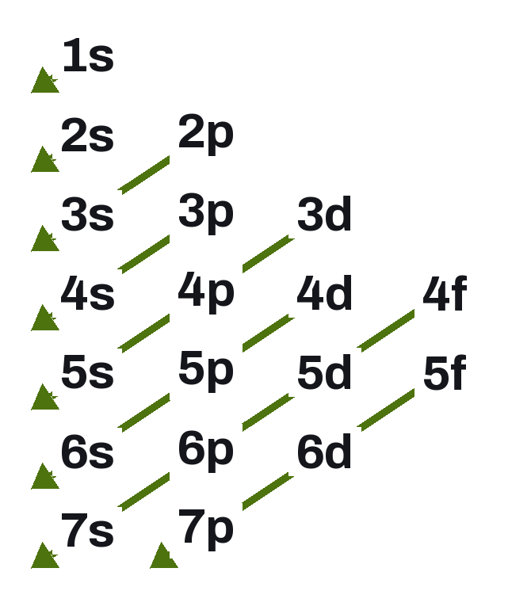 | Row 1 1s  Row 2 2s 2p  Row 3 3s 3p  Row 4 4s 3d 4p  Row 5 5s 4d 5p  Row 6 6s 4f 5d 6p  Row 7 7s 5f 6d 7p
     | ORBITALS | MAX e⁻
    s | 1 | 2
    p | 3 | 6
    d | 5 | 10
    f | 7 | 14
2s | 3  Li | 4  Be |  |  |  |  |  |  |  |  |  |  |  |  | 2p | 5  B | 6  C | 7  N | 8  O | 9  F | 10  Ne
3s | 11  Na | 12  Mg |  |  |  |  |  |  |  |  |  |  |  |  | 3p | 13  Al | 14  Si | 15  P | 16  S | 17  Cl | 18  Ar
4s | 19  K | 20  Ca |  | 3d | 21  Sc | 22  Ti | 23  V | 24  Cr | 25  Mn | 26  Fe | 27  Co | 28  Ni | 29  Cu | 30  Zn | 4p | 31  Ga | 32  Ge | 33  As | 34  Se | 35  Br | 36  Kr
5s | 37  Rb | 38  Sr |  | 4d | 39  Y | 40  Zr | 41  Nb | 42  Mo | 43  Tc | 44  Ru | 45  Rh | 46  Pd | 47  Ag | 48  Cd | 5p | 49  In | 50  Sn | 51  Sb | 52  Te | 53  I | 54  Xe
6s | 55  Cs | 56  Ba | 57–70  4f ↓ | 5d | 71  Lu | 72  Hf | 73  Ta | 74  W | 75  Re | 76  Os | 77  Ir | 78  Pt | 79  Au | 80  Hg | 6p | 81  Tl | 82  Pb | 83  Bi | 84  Po | 85  At | 86  Rn
7s | 87  Fr | 88  Ra | 89–102  5f ↓ | 6d | 103  Lr | 104  Rf | 105  Db | 106  Sg | 107  Bh | 108  Hs | 109  Mt | 110  Ds | 111  Rg | 112  Cn | 7p | 113  Nh | 114  Fl | 115  Mc | 116  Lv | 117  Ts | 118  Og

 |  | f-BLOCK · fits between groups 2 and 3 in rows 6 and 7
LANTHANIDES | 4f | 57  La | 58  Ce | 59  Pr | 60  Nd | 61  Pm | 62  Sm | 63  Eu | 64  Gd | 65  Tb | 66  Dy | 67  Ho | 68  Er | 69  Tm | 70  Yb
ACTINIDES | 5f | 89  Ac | 90  Th | 91  Pa | 92  U | 93  Np | 94  Pu | 95  Am | 96  Cm | 97  Bk | 98  Cf | 99  Es | 100  Fm | 101  Md | 102  No

READING A ROW  Read left to right and say the sublevel labels as you pass them. Row 4: 4s, then 3d, then 4p. The d sublevel is always one level lower than the row; f is two lower. | NOBLE-GAS SHORTHAND  Start from the noble gas at the end of the row above, in brackets: [He] [Ne] [Ar] [Kr] [Xe] [Rn]. Then write the rest of the row in filling order.

